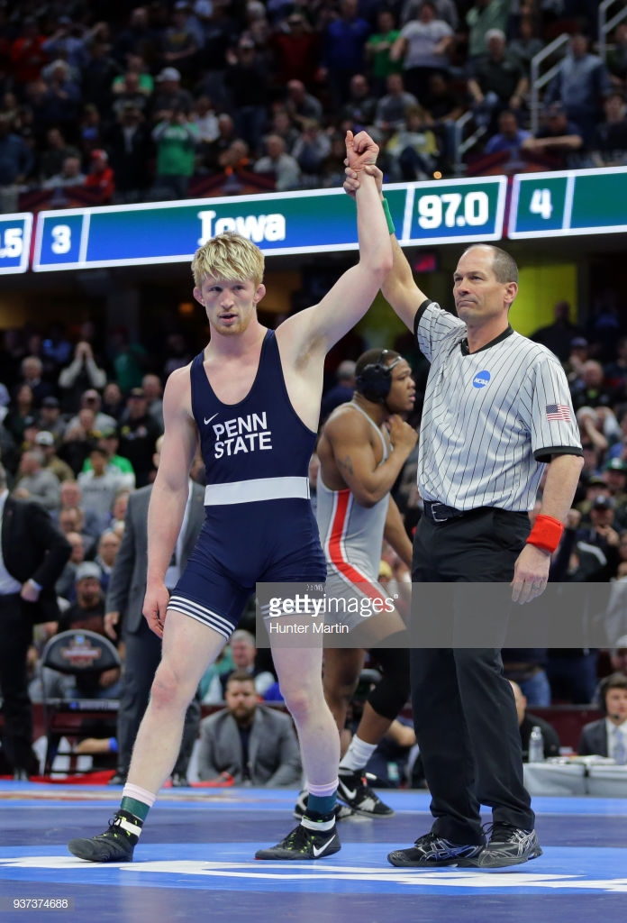
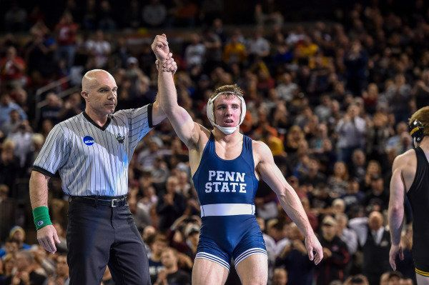
LEGENDS WRESTLING CAMP
GOTHENBURG High School

Dates & Location- June 24-26, 2020, Gothenburg High School

Registration – Mail registration to Gothenburg High School.
Questions: Contact Coach Scott 402 890 4238 or tom.scott@goswedes.org

Camp Fee- $170 per wrestler for a team of 8 or more
$185 per wrestler for an individual

Age Requirement – Second Grade through Senior in High School.

THE CAMP IS A COMBINATION OF TECHNIQUE AND COMPETITION-there will be five incredible technicians and five high school team duals and a 6 to 8 Man Round Robin Tournament with a trophy to the winners

Technicians –Mark Hall, Yianni D., Zain Retherford and Bo Nickal.

Trophies will be awarded to the winners of the day 2 tournament and high school wrestlers will get at least 11 matches.

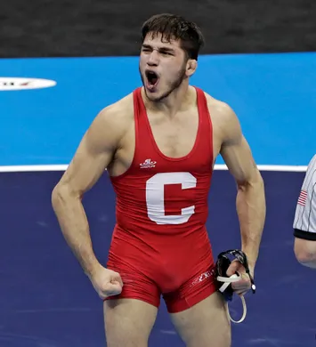
WE WILL SERVE LUNCH ALL THREE DAYS AT NO EXTRA COST

The camp will begin at 9 am all three days. Sixth grade and under will swim on Day 2 of the camp (June 25th).

The Second-sixth graders will be done at 1 pm on June 26th.
Camp will provide excellent technical advice from legendary international wrestlers Mark Hall, Bo Nickal, Yainni D., and Zain Retherford. Lunches, water bottle, and camp t-shirt are also included in the price.
Camp Registration information

Name________________________________________________________________________

Weight ___________ Grade (for 2020-2021 school year) ____________ Level (1-5)__________

Numbering for Levels 1-5
1 is a beginning wrestler with very little experience
2 is someone who won matches but lost more then they won
3 is someone who won more matches then they lost but did NOT qualify for the state tournament
4 is a state qualifier
5 is a state placer

High School or YouthTeam ______________________________________

T-Shirt Size: YS YM YL S M L XL XXL

Parent(s) names ______________________________________

Emergency # ___________________________________________

Parent’s Email address_____________________________________________________

Waiver and Release Form / Medical Information
I fully understand that the staff are not physicians or medical practitioners of any kind. With the above in mind, I hereby release the Gothenburg Wrestling staff to render temporary first aid to my child or children in the event of any injury or illness, and if deemed necessary by the Gothenburg Wrestling staff to call our doctor and to seek medical help, including transportation by a Gothenburg Wrestling staff member and/or its representatives, whether paid or volunteer, to any health care facility or hospital, or the calling of an ambulance for said child should the Gothenburg staff deem this to be necessary.

In consideration of your acceptance of this entry, I intend to be legally bound hereby for myself, my heirs, executors and administrators waive and release Gothenburg wrestling staff Mark Hall, Bo Nickal, Zain Retherford, Yainni Diakomihalis, , THEIR AGENTS, REPRESENTATIVES, COACHES, VOLUNTEERS, FROM ANY AND ALL CLAIMS OR RIGHTS TO DAMAGE FOR INJURIES OR LOSSES SUFFERED BY ME DIRECTLY OR INDIRECTLY IN TRAINING OR TRAVELING TO OR FROM OR COMPETING IN, OR ATTENDING the camp.

Parent or Guardian Signature____________________________ Date: ____ / ____ /____

Reminder: Wrestlers need to have gear to wrestle in all three days but also on Day 1 (June 19th) high school wrestlers will swim and on Day 2 (June 20th) 3rd-6th graders will be swimming.

Due to space, we will be limiting the number of participants to 425 wrestlers that are grades 7-12 and 75 wrestlers that are grades 2-6. It will be on a first come, first serve basis early registration by mail with payment will guarantee a spot in the camp.

Please return form with payment to:

Gothenburg High School Wrestling
1322 Avenue I
Gothenburg, NE 69138

